**EXPERIMENT – 8**

**AIM :**

Write the queries to implement the Set Operations.

**THEORY :**

In this experiment we will see the implementation of Set Operations. Set operations in DBMS are operations that allow you to combine or compare the results of two or more queries. These operations treat the query results as sets and perform operations based on set theory principles.

The common set operations in DBMS are **:**

* **UNION :** The UNION operation combines the results of two or more SELECT statements, removing any duplicate rows. It returns a result set that contains all the distinct rows from each query.
* **UNION ALL :** Similar to UNION, the UNION ALL operation also combines the results of multiple SELECT statements. However, it does not remove duplicate rows and returns all rows from each query
* **INTERSECT :** The INTERSECT operation returns the common rows between two or more SELECT statements. It retrieves only the rows that exist in all the query result sets, effectively finding the intersection of the sets
* **EXCEPT :** The EXCEPT operation returns the rows that exist in the result of the first SELECT statement but not in the result of the subsequent SELECT statement(s).

**PROCEDURE :**

**GIVEN TABLES:**

1. 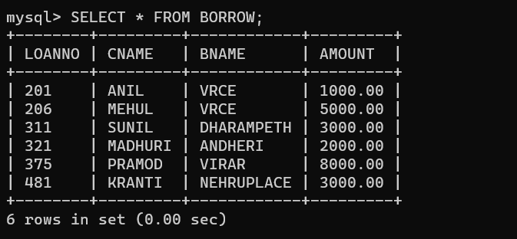**BORROW:**

**2. CUSTOMERS:**

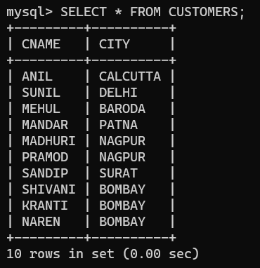

**3. BRANCH:**

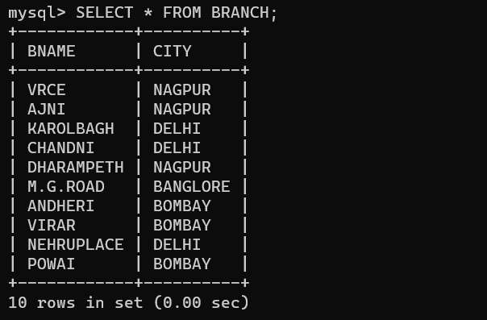

**4.DEPOSIT:**

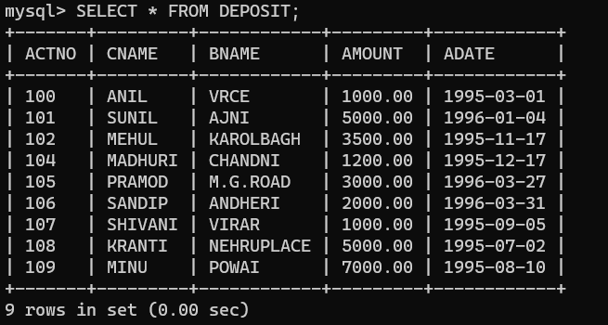

**QUERIES BASED ON SET OPERATIONS:**

**QUERY (i):** Give name of customers who are either a depositor or a borrower.

**OUTPUT:**

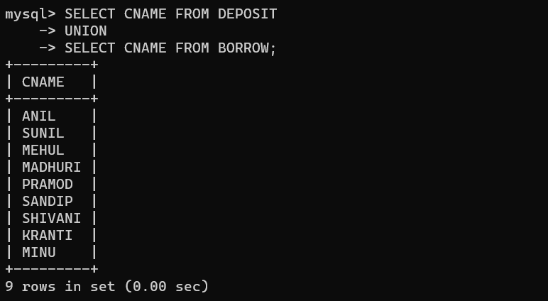

**QUERY (ii):** Give name of customers who are both depositors and borrowers.

**OUTPUT:**

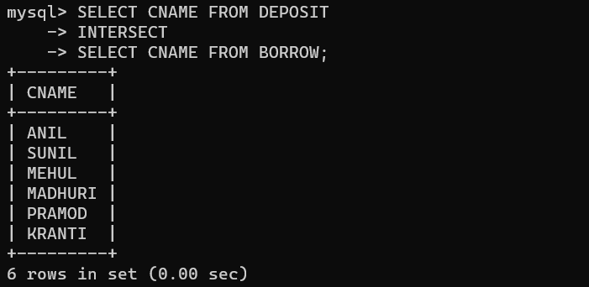

**QUERY (iii):** Give names of customers who are a depositor but not a borrower .

**OUTPUT:**

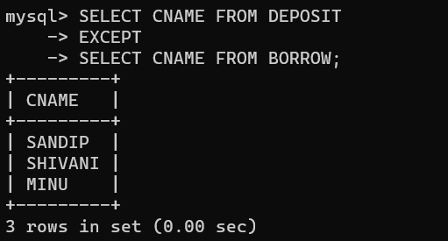

**QUERY (iv):** Combine the name of customers from deposit and borrow table with duplicates.

**OUTPUT:**

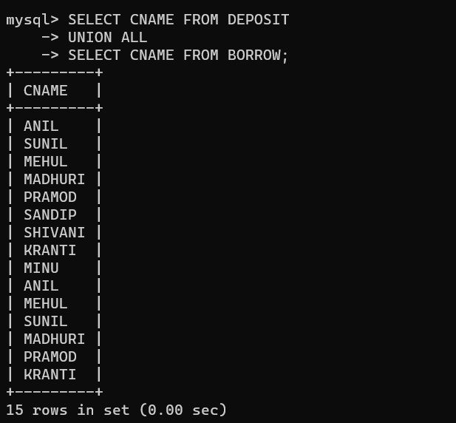

**QUERY (v):** Give name of customers who are either a depositor or a borrower but not both.

**OUTPUT:**

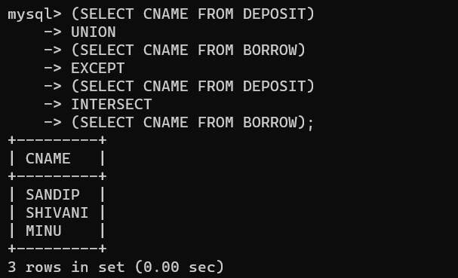

**QUERY (vi):** Give name of customers who are not a depositor.

**OUTPUT:**

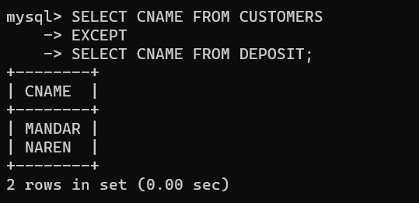

**QUERY (viii):** Give name of branches which have both a depositor and a borrower.

**OUTPUT:**

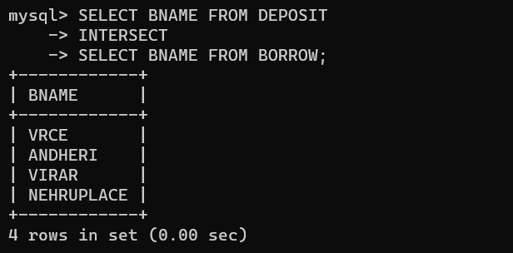

**QUERY (ix) :** Give name of branches which have a depositor and which are located in NAGPUR.

**OUTPUT:**

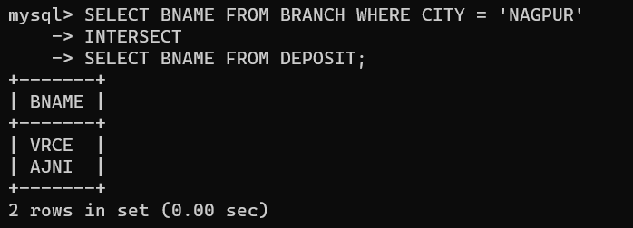

**QUERY (x):** Give name of customers which are living in NAGPUR and having a loan amount > 3000.

**OUTPUT:**

